INF 1103 Lab 4 Submission:
1: Python file (persistent_auditor.py) ✅
2: Updated inventory.txt text file ✅
3: Git Log ✅
4: Docker Mount and Run:
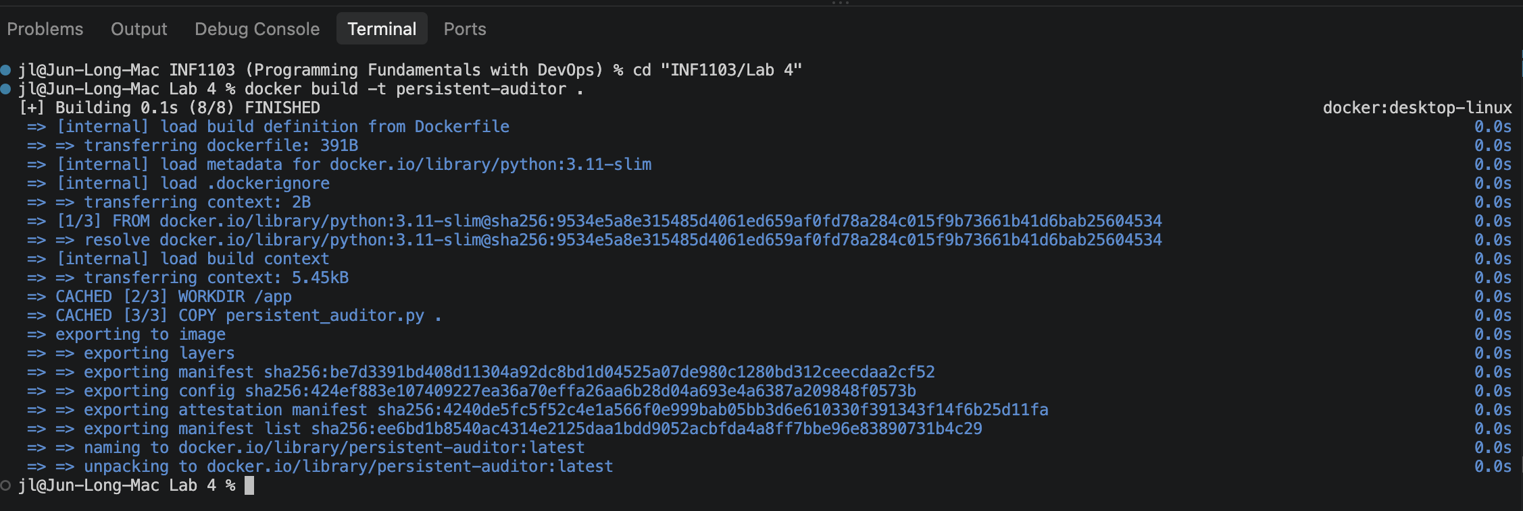
5: Evidence of image successfully built:
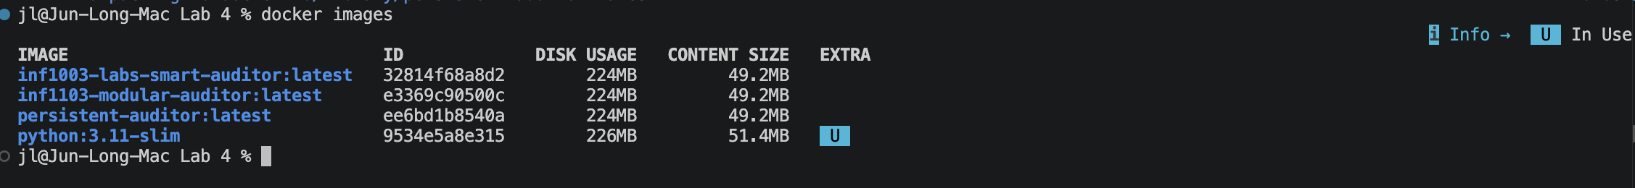
6: Proof of my persistent_auditory.py run successfully by accepting input and producing results.
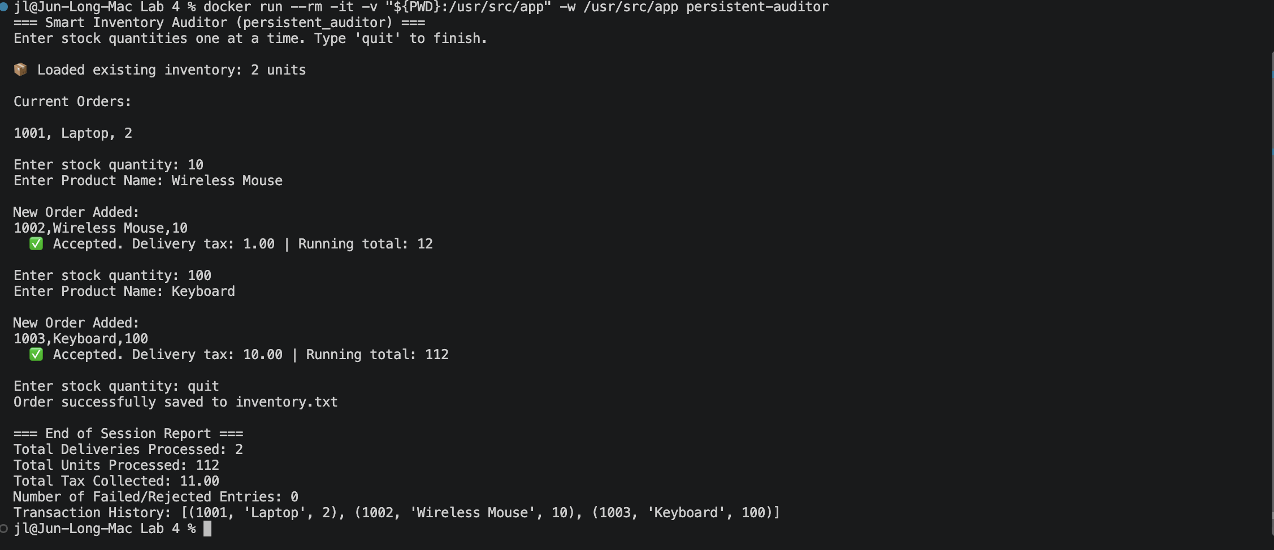

And if I run again, it will shows my current order that I have previously keyed in:
